Kammunica 240

The best 4G LTE VoWiFi Budget-Level feature phone based on Android 11 OS



**OPERATING SYSTEM**



**Feature phone based on Android 11 OS**



**LCD SCREEN**



**dot matrix display screen: 3.5 inch colorful 854*480**



**SIZE**



**200.7*215.4*27MM**



**SIM CARD**



**4G LTE VoLTE Micro SIM card**



**VOICE**



**HD Voice cancelation**



**CONNECTIVITY**



**WiFi 2.4/5.0 GHz**

**Full Cloud / Virtual PBX Connection Designed keys for Conference Transfer CAPT Pause Hold Mute Laud Speaker Volume Navigation**



**HEADSET / HANDSET**



**3.5mm Optional WiFi Wireless Handset**



**STAND**



**Upright Desk Stand or**

**Wall Hang. Screen Lock and Device Lock Mechanism**

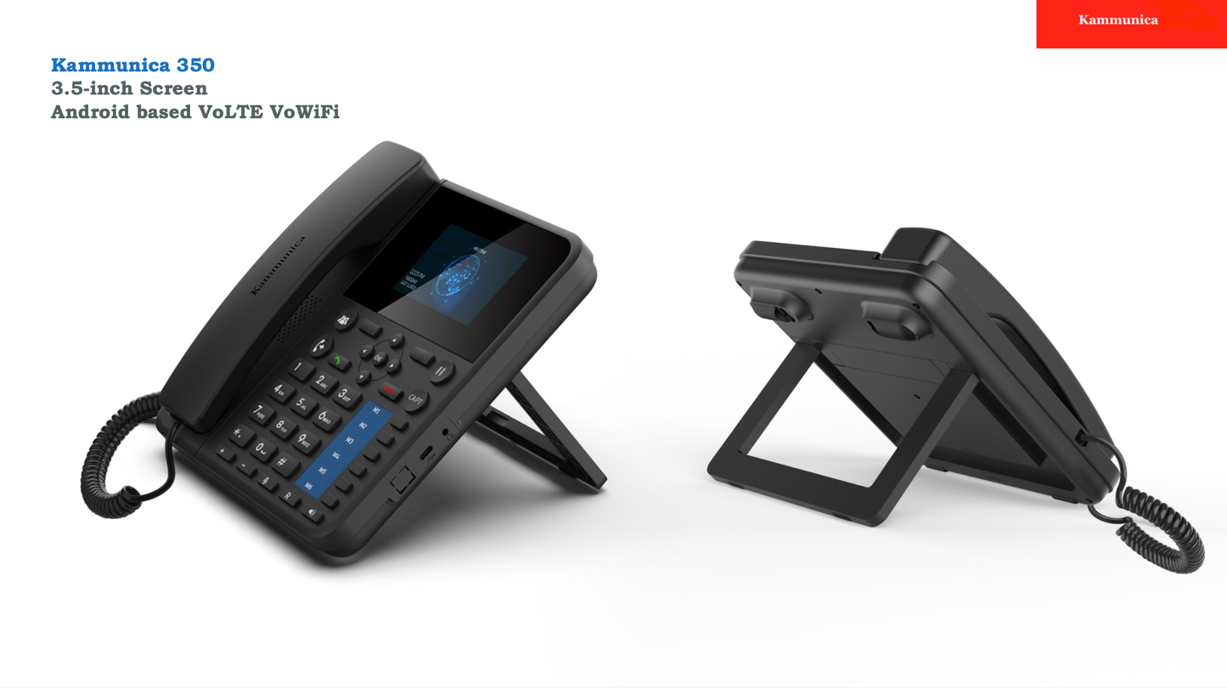



**MODULE/PROCESSOR**



**Mediatek MT6739WW**



**Power**



**C-TYPE 100V~240V 50/60Hz 0.2A; Output: 5V 1A**

**Battery 2000mAh**